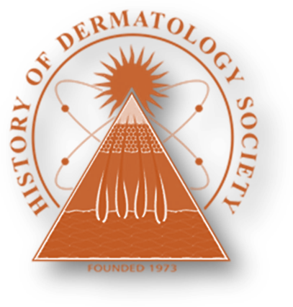

Application Form

HISTORY OF DERMATOLOGY SOCIETY

Registrant’s Name: _________________________________________________________________________
Address: _________________________________________________________________________________
City: ______________________________ State: __________________________ Zip: __________________
Country: _________________
Guests Name: _____________________________________________________________________________
Tel: ____________________ Fax: ____________________ E-mail: __________________________________
Thursday, March 6, 2025 | Price | # Tickets | Amt
Tour and Lecture - 10:00 AM  Orlando Museum of Art  2416 N. Mills Ave  Orlando, Fl 32803 | $22
Luncheon – 12:00 Noon to 1:00 PM  Rosen Centre Hotel  9840 International Drive  Orlando, FL 32819 | $50/members  $65/non-members
Afternoon Seminar – 1:00 PM to 5:00 PM  Rosen Centre Hotel  9840 International Drive  Orlando, FL 32819 | Free/members and residents  $50/non-members
Annual Banquet – Cocktail Reception – 6:30 PM  Christini’s Ristorante Italiano  7600 Dr Phillips Blvd  Orlando, FL 32819  Dinner and Samuel J. Zakon Lecture – 7:30 PM | $115/members  $155/non-members
Membership Dues – Includes a free subscription to SKINmed | $185

TOTAL: $

Please make a copy of this sheet and return it with the total amount due in $US or by check to:
The History of Dermatology Society c/o Anthony V. Benedetto,
Secretary/Treasurer of the History of Dermatology Society
2221 Garrett Road, Drexel Hill, PA 19026
Tel: 1 610-623-5885 Fax: 1 610-623-7276 e-mail: jamie@benedettoderm.com
